**Docker Part 1 Assignment – 1**

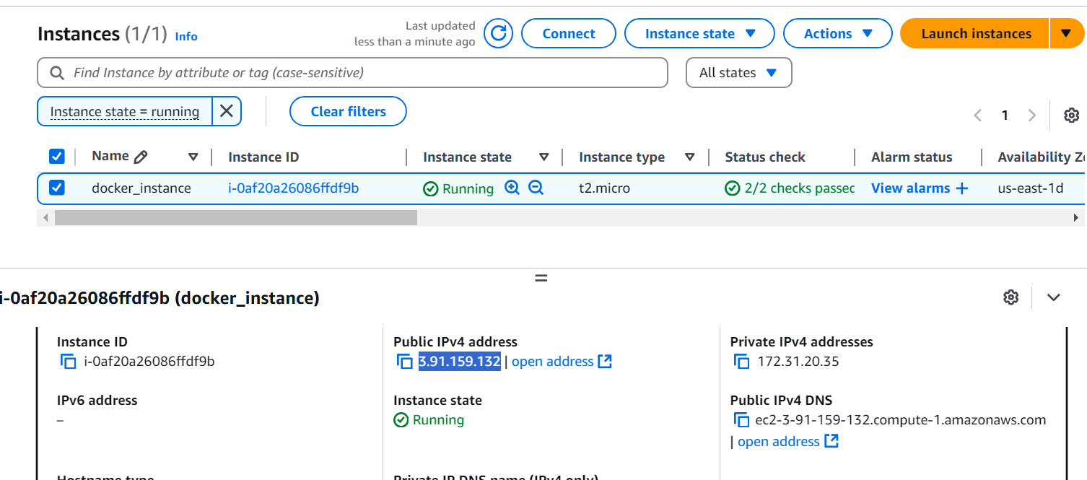

**Tasks To Be Performed:**

1. Pull Ubuntu container

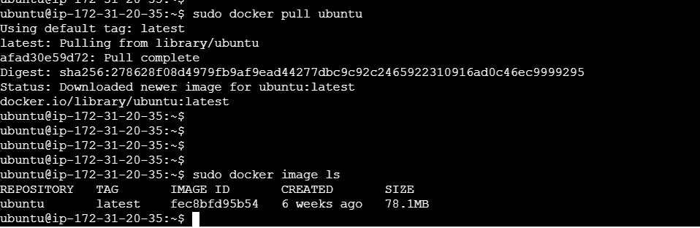

1. Run this container and map port 80 on the local



1. Install Apache2 on this container

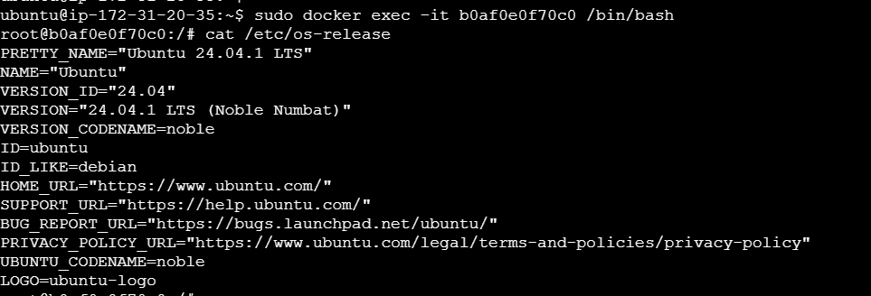

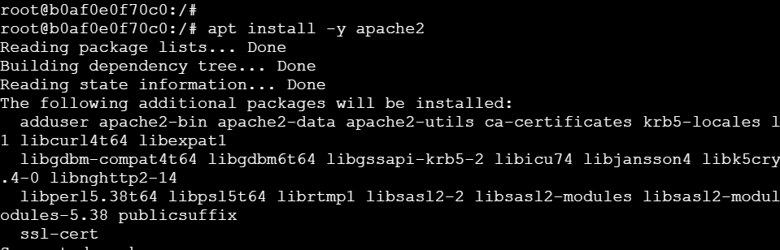

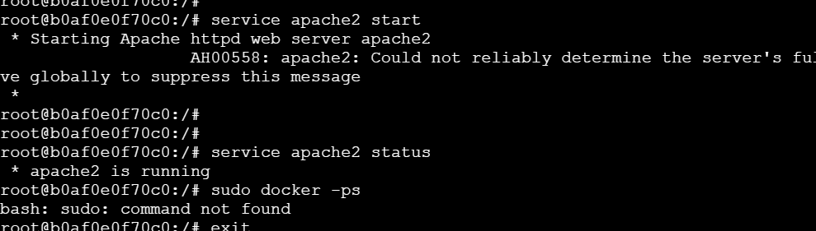

1. Check if you are able to access the Apache page on your browser

